 2012 IT APPLICATIONS

UNIT 3: ONLINE COMMUNITIES



Transition 2010 – 2011

**Student Name:** _______________________________

**Class:** **ITA3A ITA3B**

**What is Unit 3 all about?**

The focus of Unit 3 is the World Wide Web and how it supports the information needs of individuals, communities and organisations.

**Area of Study One**

For this outcome you will investigate the design and technical requirements of different types of websites that support the varying needs of online communities. You will use Dreamweaver to create a prototype website for a particular online community, taking into account the technical and non-technical constraints.

**Area of Study Two**

This outcome focuses on the use of relational database management systems (RDBMS). You will examine techniques used by organisations to acquire (get) data via websites and you will consider the relationships between how the data is acquired and the structure of an RDBMS. You will use Microsoft Access to create a database that will solve an information problem, and discuss why and how data is acquired via websites.

|  |  |  |  |  |
| --- | --- | --- | --- | --- |
| **Outcomes** | **Marks allocated** | | | **Assessment tasks** |
|  |  |  |  |  |
| **Outcome 1**  Apply stages of the problem-solving methodology to create a prototype website that meets an **online community’s needs**, and explain the technical requirements to support the hosting of this website. |  | 40  10 |  | In response to a design brief and given data:   * ***Create*** *a* ***prototype website*** capable of supporting the information needs of an online community.   **And**  A short-answer test that ***justifies*** the selected website and ***explains*** the technical requirements of the host network |
|  |  |  |  |  |
| **Outcome 2**  Design, and develop using a **relational database management system**, a solution to an information problem, and discuss why and how data is acquired via websites |  | 40  10 |  | In response to a design brief that includes an analysis of an information problem:   * The ***design*** and ***development*** of a solution.   **And**  A report that discusses ***why*** and ***how*** data is acquired via websites |
|  |  |  |  |  |
| **Total Marks** |  | 100 |  |  |

**What is an Online Community?**

______________________________________________________________________________________________________________________________________________________

______________________________________________________________________________________________________________________________________________________

______________________________________________________________________________________________________________________________________________________

___________________________________________________________________________

Online communities can be open to all or by membership only and may or may not offer moderator tools.

Examples of online communities:

* Blogs
* Chat rooms
* Forums
* Social networking e.g. Facebook and Twitter
* C:\Documents and Settings\fihl\Local Settings\Temporary Internet Files\Content.IE5\M1YV5DHK\MC900413638[1].wmfWikis e.g. Wikipedia

**Questions**

1. Are you a member of any of the online communities above? List and explain what you use them for?

*Online Community/’s:* ________________________________________________________________

______________________________________________________________________________________________________________________________________________________________________________________________________________________________________________________

1. Research one of the above online communities and answer the questions below:

* What is its main purpose? Why?

______________________________________________________________________________________________________________________________________________________________________________________________________________________________________________________

* Who are the main groups of people how use it?

______________________________________________________________________________________________________________________________________________________________________________________________________________________________________________________

* How does this online community support the collaboration and knowledge sharing for its members?

______________________________________________________________________________________________________________________________________________________________________________________________________________________________________________________________________________________________________________________________________________________________________________________________________________________________________________________________________________________________________________________________________________________________________________________________________________________________________________________________________________________________________________________________________________________________________________________________________________________________________________________________________________________________________________________________________________________________________________________________________________________________________________________________________________________________________________________________________________________________________________________________________________________________________________________________________________________________________________________________________________________________________________________________________________________________________________________________________________________________________________________________________________________________________________________________________________________

* How does this online community provide a collective identity for its members?

____________________________________________________________________________________________________________________________________________________________________________________________________________________________________________________________________________________________________________________________________________________________________________________________________________________________________________________________________________________________________________________________________________________________________________________________________________________________________________________________________________________________________________________________________________________________________________________________________________________________________________________________________________________________________________________________________________________________________________________________________________________________________________________________________________________________________________________________________________________________________________________________

**Design Elements for websites**

When designing a website it is essential that particular design elements are considered. Design elements can influence the functionality and appearance of websites.

|  |  |
| --- | --- |
| Design elements influencing the **appearance** of a website | |
| **Proportion /**  **Visual Hierarchy** |  |
| **Orientation** |  |
| **Clarity and consistency** | *Clarity:* refers to how clearly the information on a screen is presented. The screen should not be crowded with objects and features that the user finds it difficult to see the information they need. Therefore choice of font styles and sizes and resolution of graphics contribute to clarity.  *Consistency:* the use of similar, repeated or predictable features on a screen e.g. using similar layout for different pages, the use of company logos, headers and footers, font styles, numbering styles, search fields, and navigation icons or frames. Also the colour scheme of company colours. |
| **Colour and contrast** | Colours should make the information clear, readable and attractive. Conventions for on-screen colours are:   * Most easily readable colours for text are black writing on white background * Avoid using red and green together, because colourblind people have difficulty distinguishing between them. Blue and brown are also hard to read * Limit the variety of different colours on the screen. * Light or pastel shades (or white) are the best choice for backgrounds. Avoid using bright, vivid colours except for an area of the screen you wish to emphasise. * Blue is a standard colour for an unvisited hyperlink, changing to purple when visited. If other colours are chosen for links, they should be consistent. |

|  |  |
| --- | --- |
| Design elements influencing the **functionality** of a website include: | |
| **Usability/**  **Accessibility** | The website needs to be accessible to all visitors. Due to different versions of Internet browsers and different versions of plug-ins, you need to think about the special effects created in software like Flash, Java or JavaScript.  Navigation  The links used within a website to help get from page to page. Most websites will have links (buttons) on the homepage linking to the other webpage’s on their website.  Load Time |
| **Relevance** |  |
| **Structure** | The way in which the information on a website is organised. For example, the information may all be stored on one long webpage where the user will need to scroll down, or alternatively, there may be many pages linked from the home page. |

**QuestionsC:\Documents and Settings\fihl\Local Settings\Temporary Internet Files\Content.IE5\M1YV5DHK\MC900413638[1].wmf**

1. Using the same online community that you researched in Question 2 **explain** **how** the website has used two (2) design elements to enhance its **appearance**?

Also, **Justify** your response in terms of either **efficiency** (cost, time or effort) or **effectiveness** (quality of output, accuracy, presentation and comprehensiveness).

*Element 1:* _________________________________

Explanation: ________________________________________________________________________

________________________________________________________________________________________________________________________________________________________________________________________________________________________________________________________________________________________________________________________________________

__________________________________________________________________________________

Justification: _______________________________________________________________________

________________________________________________________________________________________________________________________________________________________________________________________________________________________________________________________________________________________________________________________________________

__________________________________________________________________________________

*Element 2:* _________________________________

Explanation: ________________________________________________________________________

________________________________________________________________________________________________________________________________________________________________________________________________________________________________________________________________________________________________________________________________________

__________________________________________________________________________________

Justification: _______________________________________________________________________

________________________________________________________________________________________________________________________________________________________________________________________________________________________________________________________________________________________________________________________________________

__________________________________________________________________________________

1. Now using the same online community as above **explain** **how** the website has used two (2) design elements that influence its **functionality**?

*Element 1:* _________________________________

Explanation: ________________________________________________________________________

________________________________________________________________________________________________________________________________________________________________________________________________________________________________________________________________________________________________________________________________________

*Element 2:* _________________________________

Explanation: ________________________________________________________________________

________________________________________________________________________________________________________________________________________________________________________________________________________________________________________________________________________________________________________________________________________

**Research Activities**

**Task 1: Social Networking**

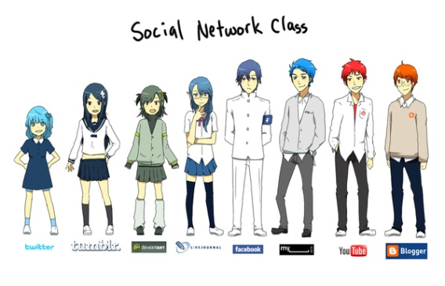Online communities use social networking services to share interests, collaborate and exchange information and knowledge. Users build on-line profiles that include pictures, blog entries, etc.

<http://www.geekstir.com/if-social-networking-sites-were-people> <http://mynerdblog.com/2011/09/social-network-class-anime-style/#axzz1dlJtGWRZ>

Using the above graphics, explain how the characteristics of two (2) social networking sites are depicted.

**Task 2: Social Media**

Watch the following YouTube videos and then list 10 amazing facts you did not know beforehand.

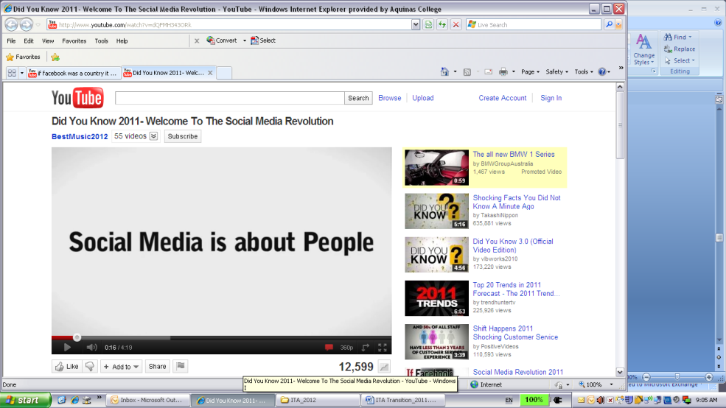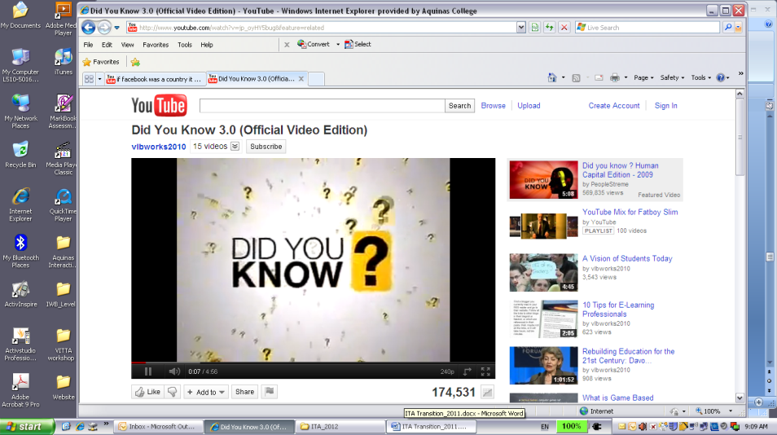

<http://www.youtube.com/watch?v=jp_oyHY5bug&feature=related> <http://www.youtube.com/watch?v=dQFMH343ORk>

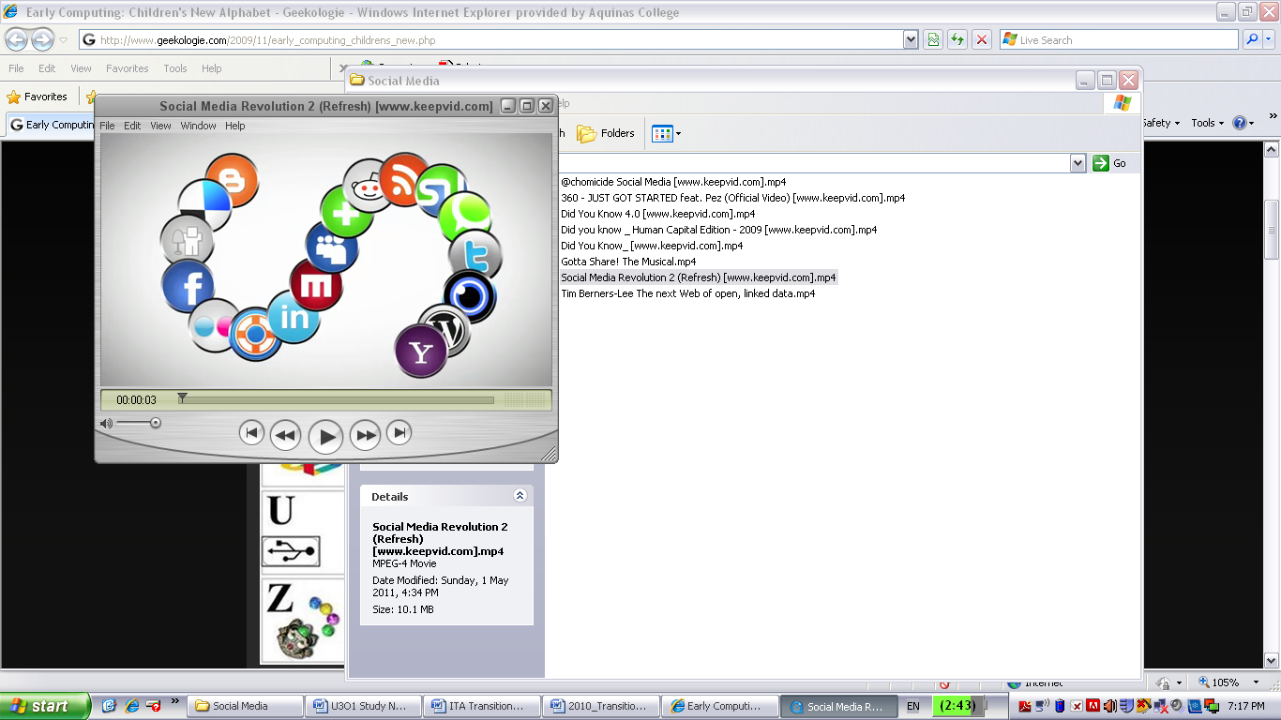

<http://www.youtube.com/watch?v=lFZ0z5Fm-Ng>

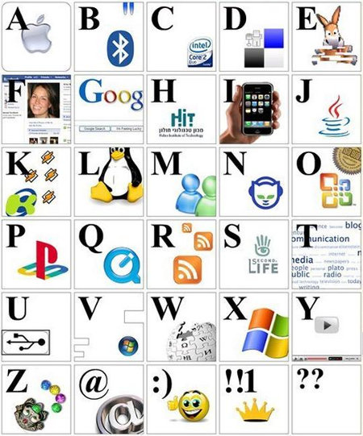**Task 3: Early Computing: Children’s New Alphabet**

Referring to the image below, what does each letter of the alphabet represent?

[**http://www.geekologie.com/2009/11/early_computing_childrens_new.php**](http://www.geekologie.com/2009/11/early_computing_childrens_new.php)

**Task 4: Social Media & Life**

Optimisng.com.au interviewed Corey Williams (basketball), Broni (singer) and 360 (rapper) on how they use social media. Select one of the interviews, and explain four (4) reasons how social media is used by the artist.

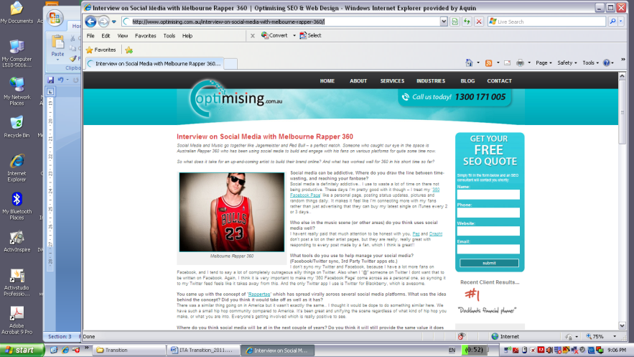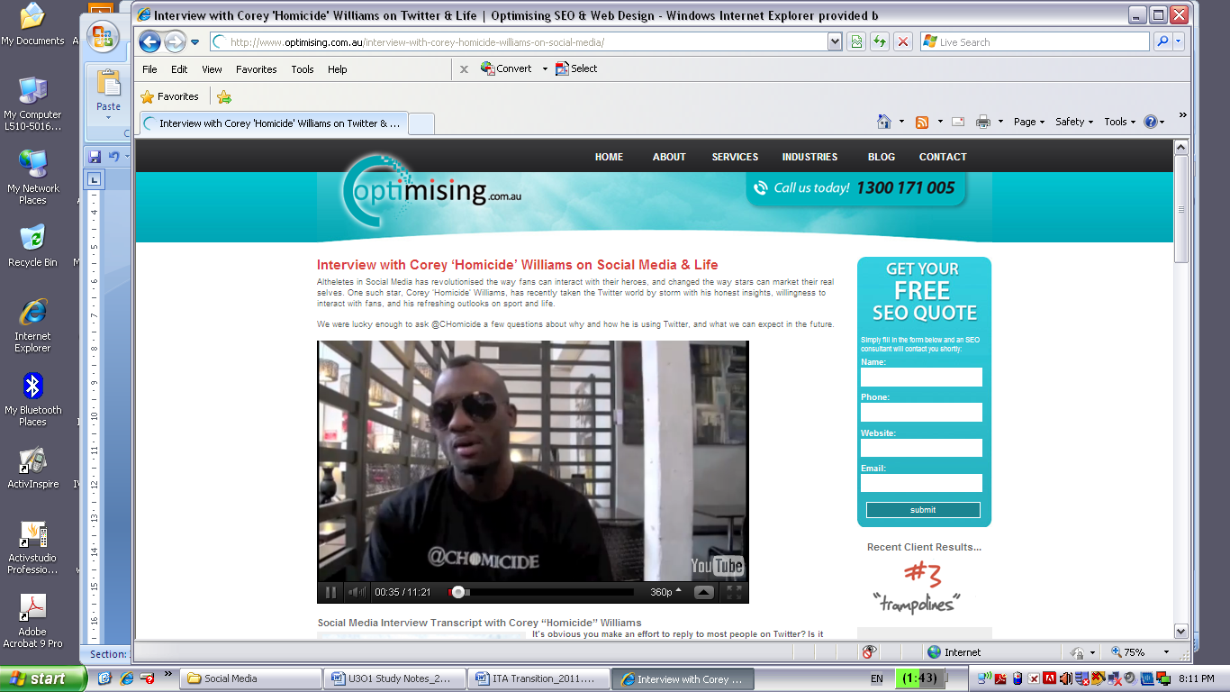

<http://www.optimising.com.au/tag/chomicide/> <http://www.optimising.com.au/interview-on-social-media-with-melbourne-rapper-360/>

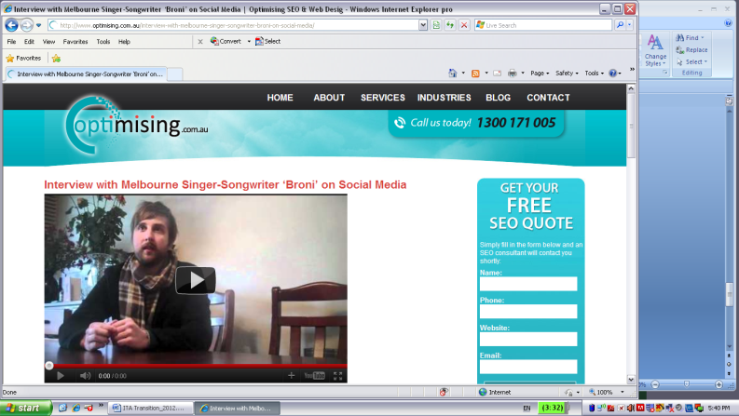

<http://www.optimising.com.au/interview-with-melbourne-singer-songwriter-broni-on-social-media/>

**Task 5: If social media was a high school…**

Explain the **purpose** of the infographic from the webpage below (200 words min.)

[**http://www.flowtown.com/blog/class-of-2011-if-social-media-were-a-high-school**](http://www.flowtown.com/blog/class-of-2011-if-social-media-were-a-high-school)

**Crossword**

|  |  |  |  |  |  |  |  |  |  |  |  |  |  |  |  |  |
| --- | --- | --- | --- | --- | --- | --- | --- | --- | --- | --- | --- | --- | --- | --- | --- | --- |
| 1 |  |  |  |  | 2 |  |  |  |  |  |  |  |  |  |  |  |
|  |  |  |  |  |  |  |  |  |  |  |  |  |  |  |  |  |
|  |  |  | 3 |  |  |  | 4 |  |  |  |  |  |  |  |  | 8 |
|  |  |  |  |  |  |  |  |  |  |  | 7 |  |  |  |  |  |
| 5 |  |  |  |  |  |  |  |  |  |  |  |  |  |  |  |  |
|  |  |  |  |  |  |  |  |  |  |  |  |  |  |  |  |  |
| 6 |  |  |  |  |  |  |  |  |  |  |  |  |  |  |  |  |
|  |  |  |  |  |  |  |  |  |  |  |  |  |  |  |  |  |
|  |  |  |  |  |  |  | 9 |  |  |  |  |  |  |  |  |  |
|  |  |  |  |  |  |  |  |  |  |  |  |  |  |  |  |  |
|  |  |  |  |  |  |  |  |  |  |  |  |  |  |  |  |  |
|  |  |  |  |  |  |  |  |  |  |  |  |  |  |  |  |  |
|  |  |  |  |  |  |  |  |  |  |  |  |  |  |  |  |  |

**Across**

1. Navigation and load time are design elements affecting the ________________ of a website.

3. A ______________ connects computers together so they can share data, information and resources

5. The name given to an online journal

6. Wikipedia is an example of what type of community?

9. Colour & Contrast is an example of a design element which influences the _________________ of a website

**Down**

1. ___________ is an example of an social networking site. You can share photos and keep in touch with friends and family

2. The ____________ is considered the biggest WAN

4. When considering how graphics should be placed on a website this is referring to? _______________

7. When creating a website you must consider the type of content you put on it. This is referred to as _______________

8. Described in terms of cost, time and effort.

**Other Homework Questions**

**Test Your Knowledge**

**(Taken from IT Applications, Nelson Education, Chapter 1)**

**Networks**

1. What are the four main advantages in using a network?
2. What compelling reason would an organization use to justify resource sharing?
3. What resources, other than printing, can be shared on a network?
4. How does file sharing on a network avoid problems associated with data duplication?

**Types of networks**

1. What are the key differences between WANs and LANs?
2. Why are network points called nodes rather than being called computers?
3. Explain the difference between a client and a server on a network.
4. Describe the roles of the following on a network:
5. database server
6. domain name server
7. proxy server
8. active directory domain controller
9. Would a peer-to-peer network be worthwhile on a small network?
10. Kazaa was a good example of a peer-to-peer network. It was slower than web servers that use a client–server model. What are the problems with peer-to-peer networks?
11. What is a switch?
12. Explain why many larger organisations prefer a star topology over a bus topology.
13. What is an intranet?**Transmission media**
14. Why do new networks use CAT 5 standard cable rather than CAT 3?
15. What are some of the disadvantages of using CAT 5 cable? Why is CAT 5 cable used in so many installations?
16. Why is fibre-optic cables often used to connect major switches inside buildings as well as between buildings?
17. What advantages does wireless networking have over a network that uses physical transmission media?
18. What limitation applies to microwave transmissions?
19. Why is radio wireless networking preferable to infra-red wireless networking?

**Network security**

1. Why does a wireless network pose a greater security threat than a wired network?
2. Recommend a password strategy that an organisation could implement to avoid unauthorised access to their network.
3. What are the main purposes of firewalls and how are these purposes achieved?
4. What added security feature should wireless networks employ?

**Holiday Homework**

Homework must be completed by the end of the first week back after the holidays. This homework has been set to assist in preparation for the following weeks’ work. It is very important that it has been completed.

Failure to do this homework will result in detentions during lunch time or after school to complete missed work and a phone call or letter will be sent home to your parents.



**Edmodo Quiz**

Your holiday homework is to complete the quiz on Edmodo. You have been allocated 90 minutes to complete it and it must be completed in 1 sitting i.e. you cannot go back and modify your answers.

To access the quiz go to:

[www.edmodo.com](http://www.edmodo.com)

Click on the ITA Transition group and then click on the relevant post to complete the quiz.

*Hint*: The quiz will have questions dealing with the content we have just learnt as well as some revision from 11 IT

Topics include: Online communities, Problem Solving Methodology and Networking